PJF Howto Image Correction.doc

Use the picture in MyClasses called crop.jpg


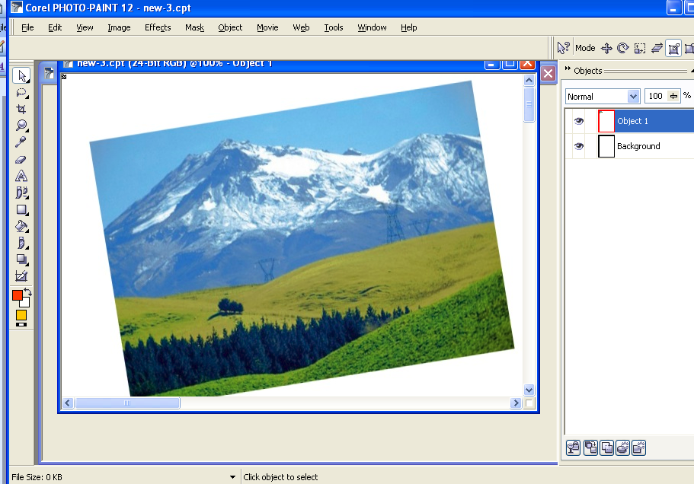

Crop and rotate the image to its correct aspect.

Insert some clouds into the sky, magic wand the sky shift clicking to select more.

Open the image clouds and Ctrl A (select all) and copy

Back to your crop image and paste as a new selection.

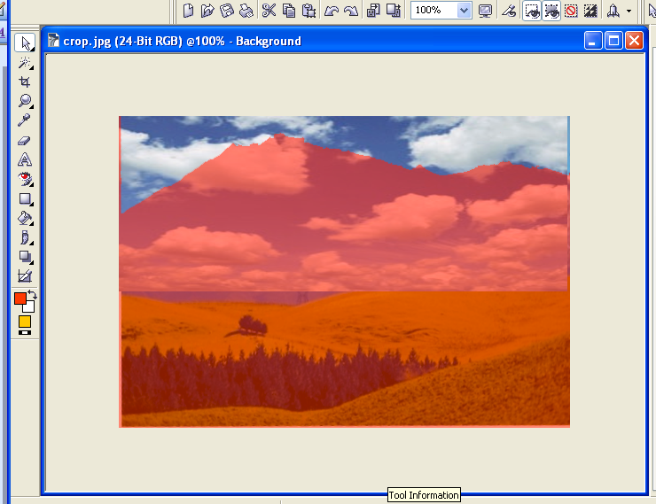
Drag the clouds image to fill the sky.

Invert the mask, copy the selection and paste it (magically your mountain will re-appear) and a new layer will be created.

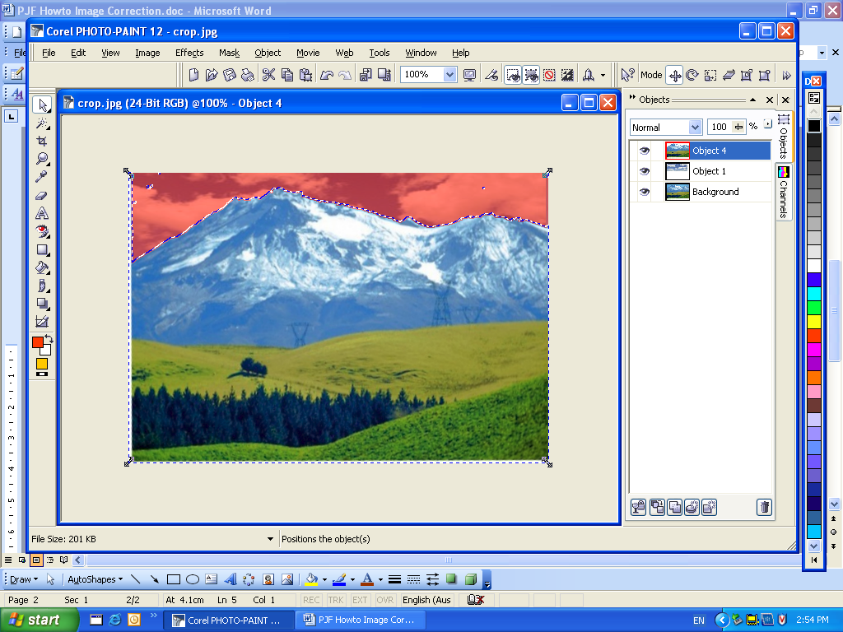

Remove the power lines using the clone tool and

Then ensure that you are only working on the foreground (mountains) turn off the eye
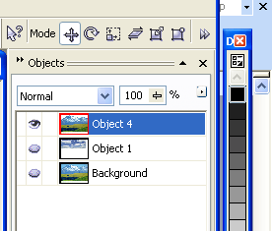

Next enhance the image using curves
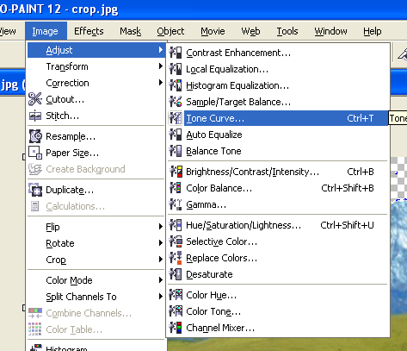
Image – Adjust

Tone Curves

Ensure that you have selected all RGB Channels

Click on the line, somewhere above above the mid point then move the slider line up or down and watch the preview.

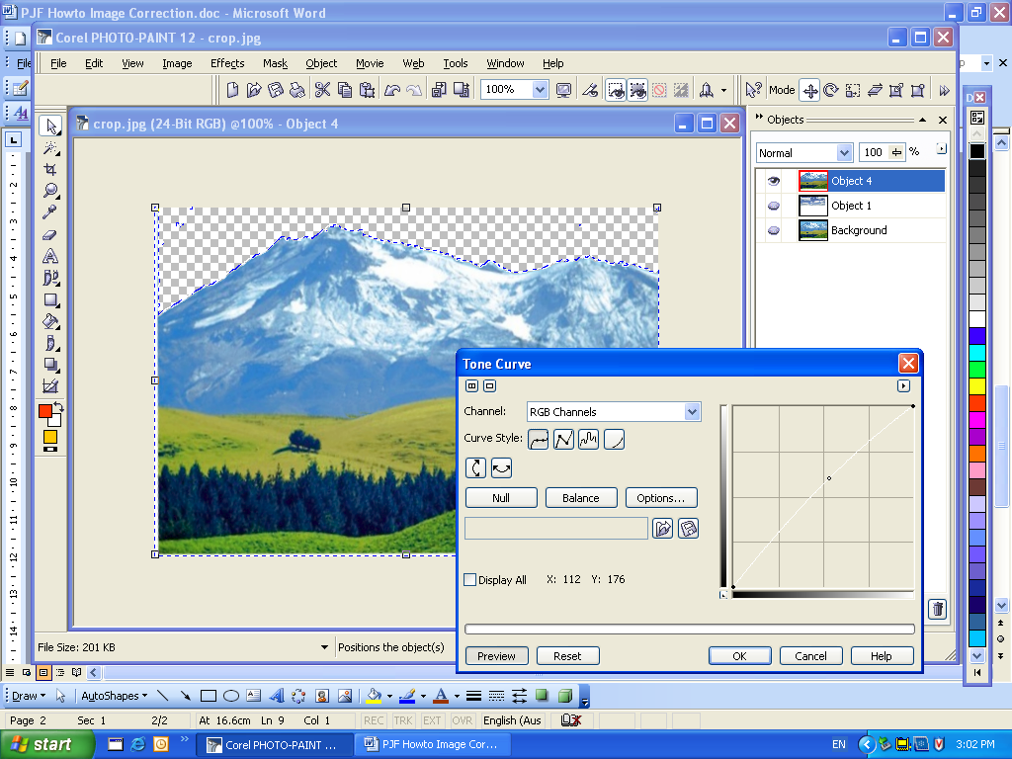

Can you make the mountains stronger?

Save the image as your initials_crop change.jpg

If the image is too large

Resample to size to change the resolution from 300dpi to 100dpi

